Stage 5 – Swinger Practice Could Have Been Helpful
COURSE DESIGNER: Ryan Christenson
SCORING: Comstock 30 rounds.
TARGETS: 14 cardboard targets, 2 steel targets
SCORED HITS: 2 Best hits per carboard will be scored.

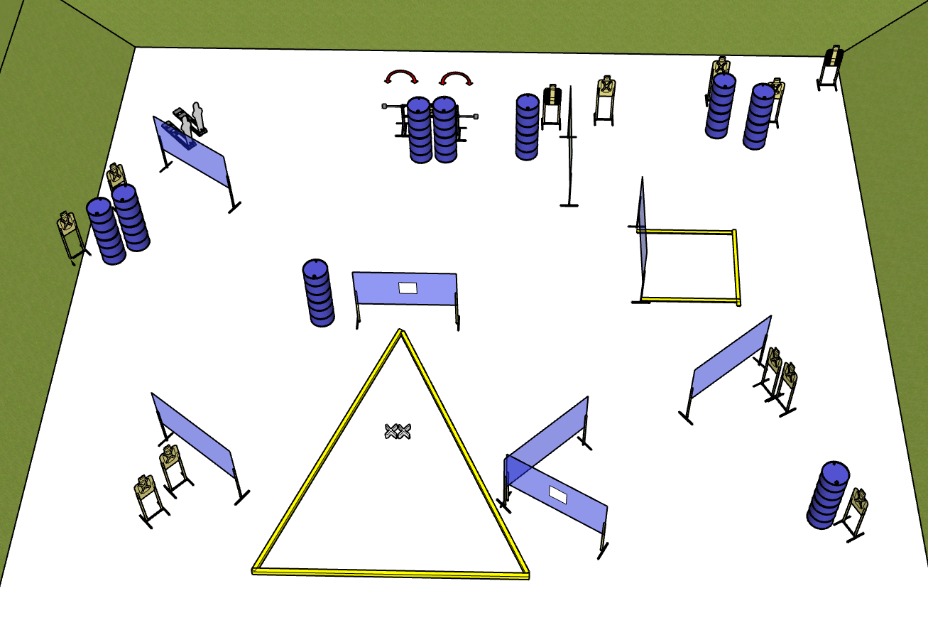

Written Stage Briefing:

Stage 5 – Swinger Practice Could Have Been Helpful - is a 30 round, 150 point, Comstock Course. There are 14 cardboard targets and 2 steel targets.

Starting with both feet on the Shooting Sports Innovations Xs.

Handgun is loaded and holstered, wrists below belt.
PCC is loaded held in both hands, stock on belt.

On the audible start signal, engage targets from within the shooting area.

USPSA / NROI Range Commands:
- Make Ready
- Are you ready?
- Standby
- If finished, unload and show clear
- If clear, hammer down and holster (Handgun)
If clear, hammer down and flag (PCC)
If clear, cylinder closed and holster (Revolver)
- Range is clear

Setup Notes:
14 Single Wall Stands
1 Double Wall Stands
6 Full Walls
1 Port Wall
13 Target stands / 28 target sticks
2 Swingers + activation cables
4 Swinger Sticks
2 Activator Poppers
18+ Barrels
